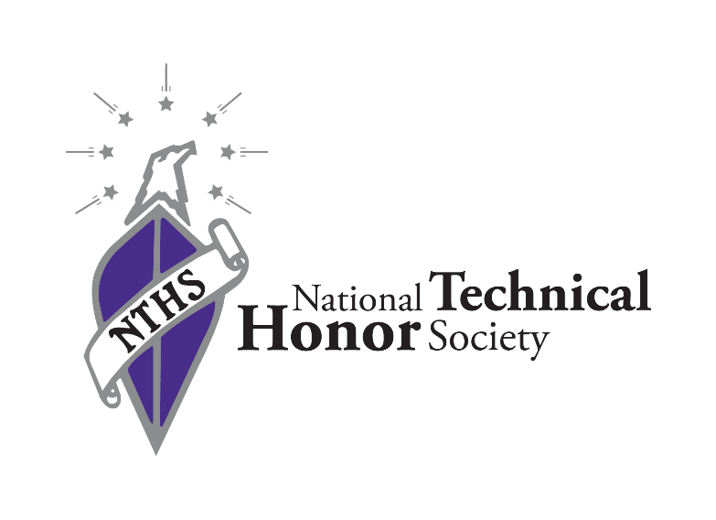

Induction Ceremony Script

Opening (Optional if you have an emcee)
Notes: If you choose, you can have an emcee kickoff the event or you could just go straight to the welcome.
Ladies and Gentlemen, welcome to the (insert year) National Technical Honor Society Induction Ceremony for (insert school). Please welcome (insert speaker name).

Welcome/History
Notes: Someone provides a personalized welcome/introduction speech to the group. It can be a school administrator, dignitary, advisor, chapter officer, alumni anyone you deem appropriate to welcome the audience. Below is a piece that includes some history, but we encourage you to personalize it.
Good Evening, I would like to welcome you to (insert school)’s National Technical Honor Society’s Induction Ceremony. Tonight, we recognize the accomplishments of a group of outstanding Career and Technical Education students who have put forth tremendous effort and shown great aptitude in their chosen trade area. Induction into the National Technical Honor Society is one the highest accomplishments that can be bestowed upon a Career and Technical Education student. Having served over 1 million members since its founding in 1984, the National Technical Honor Society was created to bring honor and recognition to one of the most critical segments of education, Career and Technical Education. From celebrating these students to awarding nearly $300,000 in scholarships each year, the National Technical Honor Society believes in empowering and supporting students in their quest to master a skill and embark in a career that they love.

Tonight, we invite you all join us in celebrating these students and supporting the time-honored purposes of the National Technical Honor Society.

Purposes of NTHS
Notes: Read by a student, advisor, administrator, alumni, pre-recorded audio, etc.
The purposes of the National Technical Honor Society are:
- To reward excellence in workforce education.
- To develop self-esteem, pride, and encourage students to reach for higher levels of achievement.
- To promote business and industry’s critical workplace values – honesty, responsibility, initiative, teamwork, productivity, leadership, and citizenship.
- To help schools build and maintain effective partnerships with local business and industry.
- To champion a stronger, more positive image for workforce education in America.
Colors of NTHS
Notes: Could be read by a student, advisor, administrator, alumni, or audio recording.
The colors of the National Technical Honor Society are silver, white and purple.
- Silver represents value and worth
- White represents truth and honesty
- Purple represents achievement and honor
Emblem & Insignia of NTHS
Notes: Could be read by a student, advisor, administrator, alumni, or audio recording.
The official emblem of the organization is made up of a shield crossed by a scroll bearing the letters "NTHS". Above the shield is the head of an American Bald Eagle with a wreath of seven stars circling the eagle’s head.

The shield represents the individual member. The line running through the shield represents a straight "plumb line", fundamental to building a life and career upon a good foundation. The Bald Eagle's head represents the United States of America and the individual’s freedom of career choice. The wreath of seven stars represents the seven attributes of the NTHS member and the individual NTHS Chapters throughout the US.

The official insignia of the organization which is used on all charters, membership certificates, documents and stationery is made up of the official NTHS emblem as its central figure and also an arch upon which are inscribed the seven attributes of the membership (skill, scholarship, honesty, responsibility, service, leadership, and citizenship), the year the Society was established (1984), and the motto of the organization. The arch itself represents the student's passage from school or college into the workforce; the steps represent the preparation necessary to make that transition.

Motto of NTHS
Notes: Could be read by a student, advisor, administrator, alumni, or audio recording. The motto of the National Technical Honor Society is “Success favors the prepared mind.”

Slogan of NTHS
Notes: Could be read by a student, advisor, administrator, alumni, or audio recording.
The slogan of the National Technical Honor Society is: “Excellence in America’s workforce begins with excellence in workforce education.”

Installation of Officers
Notes: Could be done by chapter advisor, administrator, alumni or current chapter officers. There is an extended version* of the officer installation that goes position by position listed below if you would like to use it instead.
At this time, we will introduce and install the incoming (insert school) NTHS chapter officers for the (insert school year).
Your Treasurer:______________
Your Secretary: ______________
Your Vice President:____________
Your President:_____________

Officers elect, please repeat after me:
I, (state your name),
promise to uphold the ideals of the National Technical Honor Society
and to
fulfill the duties of my office as a chapter officer
to the best of my ability.

I now declare you duly elected and installed as (insert school) NTHS chapter officers for the (insert school year).

Candle Lighting Ceremony
Notes: Could be read by a dignitary, advisor, administrator, alumni or chapter officer.
In preparation for our induction and recognition ceremony, we will light the candles that represent the attributes we adhere to as members of the National Technical Honor Society.

In the center of the table is a lighted candle representing KNOWLEDGE. Knowledge is familiarity, awareness, or understanding gained through experience or study. This candle represents the knowledge you have gained through experience and study in your technical program.

The FIRST member attribute is SKILL.
SKILL is the use of knowledge to develop great ability and expertness necessary to make a positive difference in a particular occupational field.

The SECOND attribute is HONESTY.
HONESTY is the quality of being truthful, trustworthy, and fair with everyone while at work or play.

The THIRD attribute is SERVICE.
SERVICE is giving assistance and being ready and able to provide a helpful and useful act.

The FOURTH attribute is RESPONSIBILITY.
RESPONSIBILITY involves the ability to act without guidance or superior authority and being answerable for your action.

The FIFTH member attribute is SCHOLARSHIP
SCHOLARSHIP is the distinctive mark of one who has mastered an area of learning, as reflected in the quality of his/her work, especially with respect to scope, thoroughness, and care.

The SIXTH attribute is CITIZENSHIP.
CITIZENSHIP is being entitled with full civil rights and exercising the duties, rights, and privileges of this status.

The SEVENTH member attribute is LEADERSHIP.
LEADERSHIP is the responsibility of serving as a guiding force, and directing the way by going first with courage and confidence.

Fellow members, I hope you recognize these seven attributes in yourself and value these qualities that make you eligible for membership in the National Technical Honor Society.

Recognition of Second- & Third-Year Members
Notes: Could be read by an administrator, dignitary, alumni or advisor.
At this time, we would like to recognize our second- and third-year members of NTHS. These students have maintained the standards of NTHS and continued to excel in their pathway. Please help us in congratulating the following students as they receive their pins.

READ NAMES

Induction Ceremony
Notes: Could be read by an administrator, dignitary or advisor.
Now to induct and recognize our new National Technical Honor Society members. The following students embody the attributes of our organization and represent excellence in Career and Technical Education.

READ NAMES

Inductees; you are now members of the National Technical Honor Society. Please confirm this by reciting your pledge of membership.

Recitation of the Pledge
Notes: Could be read by a student, advisor, administrator, alumni or with an audio recording. For online purposes, we suggest either read and repeat or simple recitation.

As a member of the National Technical Honor society, I pledge to maintain the highest standard of personal conduct. I will apply myself to continue a record of scholastic achievement, and I will strive for excellence in all aspects of my education.

I will invest my talents, my skills and my knowledge in a career of my own choosing, and shall always endeavor to uphold my obligations as a citizen of my community and my country.

READER: I now declare you duly inducted as members of the National Technical Honor Society.

Closing Remarks
Notes: Final, personalized remarks from a dignitary, advisor, school administrator, alumni or chapter officer.
On behalf of (insert school), we would like to congratulate all of you on your hard work and installation into the National Technical Honor Society. This is an honor that you will be able to carry with you throughout your education and your career. Congratulations and welcome to the National Technical Honor Society!

*Optional Extended Officer Installation
Leaders develop through a never-ending process of self-study, education, training, and experience. Serving as an officer in this organization is will not only allow you to gain experience, but will provide an opportunity for you to help grow and mentor future leaders for your chapter as you serve your members.
One of the purposes of the National Technical Honor Society is to promote the ideals of service, leadership, and skill development among America’s future workforce.

With this in mind, it is my pleasure to install the new officers of the (School name) Chapter.

___________________(Name of Historian), would you please step forward? As Historian it is your responsibility to maintain the historical records of the chapter. You shall gather and record information including, but not limited to names of all club members and leaders each year, copies of the club program plans, news clippings, and pictures about club events and activities, etc. Do you pledge to fulfil the duties and responsibilities of Historian and to serve, to the best of your ability, the members of your chapter? If so, answer I do.

___________________(Name of Treasurer), would you please step forward? As Treasurer it is your responsibility to maintain the financial records of the chapter. You shall have general charge of the finances under the supervision and approval of your school administration and advisors. All financial transactions must comply with local school policy. Do you pledge to fulfil the duties and responsibilities of Treasurer and to serve, to the best of your ability, the members of your chapter? If so, answer I do.

____________________(Name of Secretary), would you please step forward? As Secretary it is your responsibility to chronicle the business of the chapter through complete, accurate, and timely minutes of all meetings. It is also your duty to keep all chapter records and carry on the correspondence of the chapter. Do you pledge to fulfil the duties and responsibilities of Secretary and to serve, to the best of your ability, the members of your chapter? If so, answer I do.

_____________________(Name of Vice President), would you please step forward? As Vice-President it is your responsibility to preside at all meetings of the chapter in the absence of the president. As Vice President it is also your duty to oversee all committee activities, act as the general assistant to the President, and chair the executive committee. Do you pledge to fulfil the duties and responsibilities of Vice President and to serve, to the best of your ability, the members of your chapter? If so, answer I do.

______________________(Name of President), would you please step forward? As President your duties and responsibilities are vast and varied. As the chief executive officer of this chapter, it will be your overall duty to maintain the organization’s health during this school year. You shall cooperate with the chapter advisors, the school administration, and with the chapter executive committee to supervise the general activities of the chapter. The President will preside at all meetings, appoint committees, and shall represent the chapter at official organization gatherings. Do you pledge to fulfil the duties and responsibilities of President and to serve, to the best of your ability, the members of your chapter? If so, answer I do.

At this time, it is my pleasure to present the President with this gavel. I now turn the reigns of leadership over to the chapter President, _____________________.

Additional Officer Template:
If you choose to add affectional officer positions, please use this template when you install them.

____________________(Name of ADDITIONAL OFFICER), would you please step forward? As ADDITIONAL OFFICER it is your responsibility to INSERT DUTIES OF THIS POSITION. Do you pledge to fulfil the duties and responsibilities of ADDITIONAL OFFICER and to serve, to the best of your ability, the members of your chapter? If so, answer I do.

